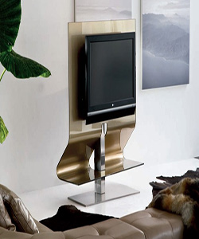

Adjustable Durian TV Stand

$98.03

Availability: In stock

### Description

A midcentury modern update on a traditional Asian design, this sleek and chic room TV trolley is a sophisticated addition to any ensemble. Available in a curated selection of metallic finishes, this unit’s frame is crafted of solid pine wood, while rice-paper inspired white panels feature linear overlays. Rounding out the design, metal hinges make folding and storage a breeze when not in use. Adjustable TV Stand Standard Finish in Black or Extra White Glass Available Special Order in Red or Extra White Champagne Glass Satin stainless steel frame Concealed wiring Glass shelf Swivel functionality TV width should not exceed 42" Made in Italy